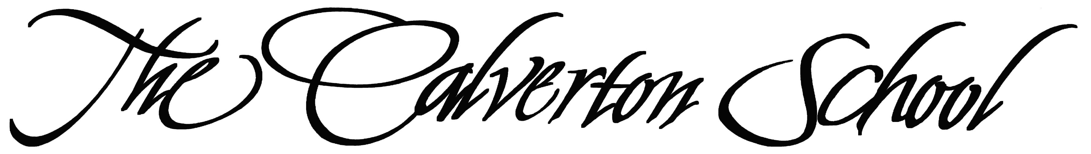

Middle School

Summer Reading, 2023 - 2024
Rising Grade 7 English

Follow the guidelines below.

- Read DK Eyewitness Book: Medieval Life. By Andrew Langley (Hardcover or Paperback)

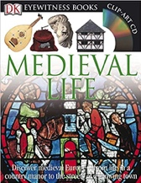
You will be studying the medieval era in seventh grade history, so this will provide you with important background information. You can find this book on Amazon or other bookstores.

- Read at least one of the following works and keep a reader’s journal

Roll of Thunder, Hear My Cry, by Mildred D. Taylor.
Catherine, Called Birdy, Karen Cushman
From the Mixed-Up Files of Mrs. Basil E. Frankweiler by E.L. Konigsburg
A Wrinkle in Time by Madeline l. Engle
The Hobbit by J.R.R. Tolkein
The Golden Compass by Philip Pullman

Guidelines for reader’s journal:

- Pick a journal or notebook. Please do not use a digital journal.

- Include an entry header indicating date and some kind of title: Each time you sit down to read, make an entry. Entries do not need to be the same length or the same type. Note page numbers referred to.

  - Make some entries creative:
    - If you are artistic, draw or paint something that caught your imagination.
    - If you are a poet, write poems or lyrics about something that happened or about a character or place.
    - Make a map, showing where events take place, or where the character has travelled.
    - Make a chart or mind map of all the characters and their relationships.

  - Make some entries academic:
    - Personal thoughts and reactions: Be reflective; think about why you may be responding the way you are. Leave room for recording later reflections on the same topic/event/character. One way to do this is to take notes on the left-hand page of notebook and reserve the right-hand page for later additions, comments, questions, and so on.
    - Comments/questions on plot, structure, point of view, characterization, or setting:
    - Plot: What is the main conflict/minor conflicts? How are conflicts related? What causes them? Where does the climax occur and what causes it? How is conflict resolved? Do some conflicts go unresolved
    - Narrative Structure: Is the narrative chronological, or does it jump around in time, with flashbacks? Does the writer use foreshadowing? Irony?
    - Point of view: Who tells the story? Do you trust the narrator to give an honest account of events and characters, or is the narrator obviously biased? How does the narrator affect your reading of the story?
    - Characterization: How are characters introduced and developed? Who do you find sympathetic and whom do you dislike? How and why do characters change? What do they learn? What problems do they have? Do they have traits that contradict one another and therefore cause internal conflicts? Do they experience epiphanies?
    - Setting: Where does the action take place? (Think not only about geographic location but also physical space: indoors, outdoors, small rooms, palatial homes, etc.) Describe this place. At what period in history does the action unfold? What is going on in society at that time that is affecting the character or causing conflict?
    - Quote and comment: Record and discuss favorite or interesting quotes in your journal

  - Final impact of the story. At the end of the book, take some time to record the overall impact the story had on you. Did the story flow well and keep you engaged, or did it feel uneven? What impact did characters have, if any, on you personally?

