IB Visual Arts Summer Work
Year 1 (HL & SL)
Ms. Gallagher – ngallagher@calvertonschool.org

Welcome to your journey into the IB Visual Arts! Your time in IB art should be both truly enjoyable and challenging to push you and your artmaking to new levels. What I ask is that you are willing to take risks and put time and effort into this course. Every piece of art and new skill you work on will be worth the learning experience, even if you don’t deem it successful; this program is as much about the process as it is the final portfolio. Ultimately, your art portfolio will be what you make of it, but I will be there to guide and encourage you through your program.

The following summer work will help get you started in art the first few weeks of school. These assignments will be graded, so please complete them by the first day of class. Over the summer, keep all your previous artwork, think about the art you already know you like and the art you want to try, take pictures, find inspiration, and keep your artistic eye open! Have fun working this summer, and please feel free to contact me with any questions.

Materials Needed for Summer Work:
- Visual Arts Journal – The exact sketchbook you use is up to you, but I suggest a hard cover sketchbook that is bound on the side. The Canson sketchbook from Blick Art item # 10350-1011 is a good choice. You want something sturdy and big enough (9x12) to hold your work. This journal will be where you complete your summer assignments and continue to work throughout the 2-year program.
  - Reminders when working in your sketchbook – never rip out pages or trash anything you make, because even practice sketches or “failed” attempts can be useful to show the progression of your work! Also, cite your images and sources – you will want to find your references or inspirations later and will need to cite these all in IB. Always record artist, title, medium, date, dimensions, location/gallery.
  - Maintaining your visual arts journal over two years will be used to document:
    - the development of art-making skills and techniques
    - experiments with media and technologies
    - personal reflections
    - their responses to first-hand observations
    - creative ideas for exploration and development
    - their evaluations of art practices and art-making experiences
    - their responses to diverse stimuli and to artists and their works
    - detailed evaluations and critical analysis
    - records of valued feedback received
    - challenges they have faced and their achievements
- A folder, binder, or accordion file folder to keep loose sketches, pictures, and other items organized in.
- Drawing pencils, colored pencils, pens, and maybe a small watercolor palette or acrylic paints. Since you will be working at home over the summer, gather some basic art supplies you want to have available when working in your Visual Arts Journal.

IB Visual Arts Summer Work
Year 1 (HL & SL)
Ms. Gallagher – ngallagher@calvertonschool.org

* The following three summer assignments will be due on the first day of class. These should be completed in your Visual Arts Journal, at least 10 complete pages (more if you choose). *

Assignment 1: Art Vocabulary
Elements of Design – COLOR, LINE, SHAPE, FORM, SPACE, VALUE, TEXTURE
Principles of Design – BALANCE, EMPHASIS, CONTRAST, PROPORTION, MOVEMENT, RHYTHM, VARIETY, PATTERN/REPETITION, UNITY/HARMONY

- Define each of the Elements and each of the Principles in your own words.
- Find a piece of artwork that depicts the term clearly, note how the term is present in the piece, and glue the image into your journal. (Cite all your images!)
- Create a small sketch with your own interpretation of this in your journal – this can be in any art form you would like, and again note how the term is present in the visual.

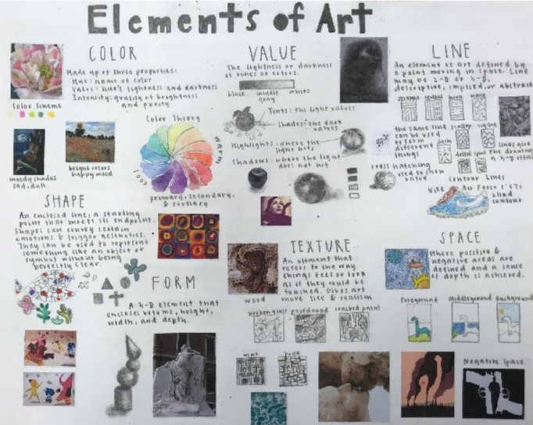
*Sample journal pages – you can be creative within your own journal and organize this vocabulary in the way that works for you as long as you complete each task. * Understanding these art terms will help you with your summer work and will be important for you to have a strong foundation as you progress through this IB course. Please complete these in the first several pages of your arts journal.
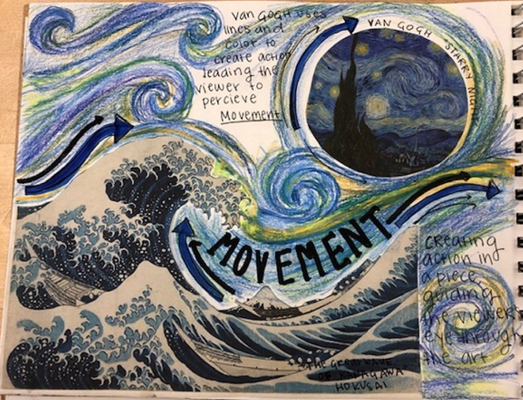

Assignment 2: Museum/Gallery Visit and Analysis
- This summer, visit a museum or art gallery. If you are near Calverton, DC and Baltimore are full of art museums. Local galleries and art shows or ones you visit on vacation are also great.
- Find a piece that catches your interest for whatever reason. Analyze it in your arts journal.
  - Include a citation: artist’s name, title, medium, date/period of work, name of gallery.
  - Include a picture of the piece or sketch of it in your journal.
  - Complete at least one page of your analysis and interpretation. Try to use specific terminology (ie. Elements and principles of art) and include as much detail as possible!

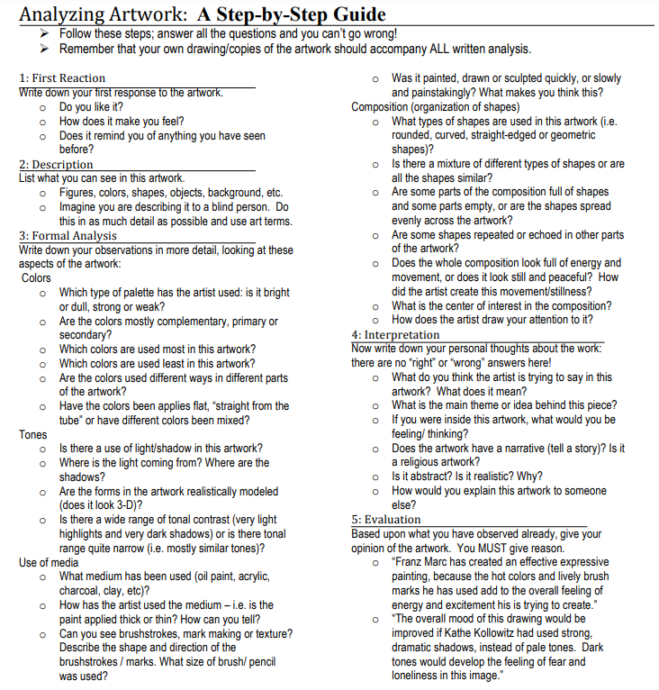

Assignment 3: Reflection - Who am I and What do I Like?
- In your art journal, create at least 5 pages of visuals and writing of who you are and what things interest you. Include topics and subjects that interest you, art techniques and processes you like, styles and artists that inspire you, ideas or philosophies you value, and things that capture who you are and how you see yourself.
- Each page should be different and focus on one theme (for example, a page all about your favorite artist(s), another page about your art in your most often used medium, etc.) so you will have at least 5 different themed pages. You can include pictures and drawings, but all pages need to include your thoughts in writing as well.
- Once you have finished the 5 pages, complete one more final page. In your final page, come up with a new project idea based on your reflections and explorations.
  - This can be any type of work, subject matter, and any medium. Consider what medium you would use to complete this piece, and sketch out ideas for a final piece in your journal. Include your thoughts and ideas in written form as well.

*Sample journal pages: Be creative, be thoughtful, be thorough! *
