Name: _____________________________
- What is the property of an object to resist changes in its motion called? (1pt)
- Distance traveled per unit time is called ________. (1pt)

- Please briefly describe the difference between mass and weight. (4pts)

- What do we call a quantity that describes an object’s speed plus direction? (1pt)

- If you are moving in a circle while moving at constant speed, are you accelerating? In a sentence or two, explain WHY or WHY NOT. (4pts)

- In terms of forces, what does it mean for an object to be in equilibrium? (2pts)

- If an object is moving to the right while sliding on a rough surface, then in what direction does the friction act upon the object? (1pt)

- In making a scientific hypothesis, we claim that the hypothesis must be falsifiable to be scientific. What do we mean by the term, “falsifiable?” (2pts)
- Why do we call the support force acting on an object by a surface the “normal” force? What does “normal” mean in this case? (2pts)
- If Bobby pushes on a box with a force of 20 N to the right and Gabriel pushes to the left on the box with a force of 13 N to the left, what is the net force? (Include magnitude, direction, and unit). (3pts)

- Jimmy pushes on a crate with a force of 35 N. However, the crate does not accelerate, as it moves at constant velocity. How is this possible? What are we missing from the picture? (3pts)

- True or False: If Kiki touches a cold table’s surface, heat flows from the cold surface to her hand making her hand colder. Why? (1pt)

- True or False: It is possible for a moving object to be in equilibrium. If true, offer an explanation. If false, say why not. (2pts)

- The measure of disorder or chaos in a system is what scientists call the system’s __________: (1pt)
  - Energy
  - Entropy
  - Heat

- An egg may fall and break. However, it does not magically put itself back together like Humpty Dumpty and rise to its original height. This is because ___________ always increases. (1pt)

- Which feels colder to the touch at 45 degrees Fahrenheit, a sweater made of wool or a sweater made of platinum? Explain your answer using the following terminology: Conductor, Heat. (3pts)

- Heat transfer by means of the movement of particles with a material, like an iron skillet in contact with a stove, is called ___________. (1pt)
- The transfer of heat via the transmission of electromagnetic waves is called __________: (1pt)
  - Convection
  - Conduction
  - Radiation

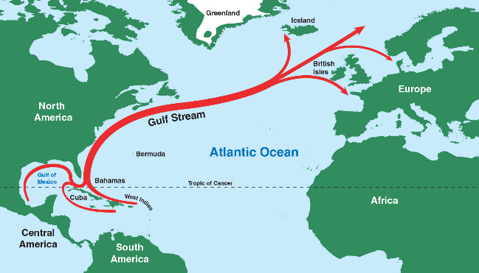
- Heat transfer by means of the movement of fluid, as occurs when the Gulf Stream ocean current carries heat from the Gulf of Mexico to Northwest Europe, is called __________: (1pt)
  - Radiation
  - Conduction
  - Insulation
  - Convection

- Explain one reason why solid ice tends to float on liquid water and not the other way around using the word “density.” (2pts)

- Why does Seattle, on the Pacific Ocean, have a milder climate than Kansas City, which is in the interior of the country but further South than Seattle? In your answer, use the following terminology: Specific Heat Capacity. (2pts)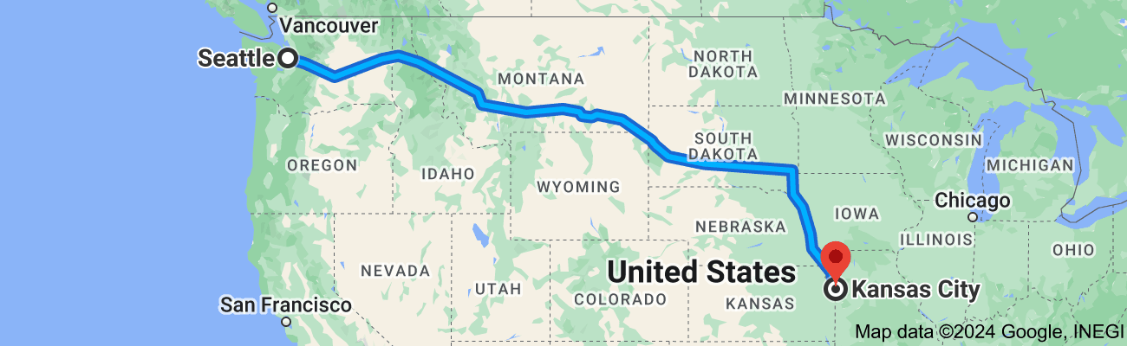

- What units do we use to measure heat? (1pt)
  - Joules
  - Calories
  - calories
  - Kilograms
  - A, B, C, but not D

- Does it make sense to say that an object’s temperature is -5 K? Why or why not? (1pt)

- What causes heat to flow? (1pt)
  - Thermal Energy
  - Temperature Difference
  - Coldness

Questions are worth 3 points, one for using the correct equation (setting up the problem correctly), one for solving correctly, and one for using the correct sign (direction) and units on the answer. You may use a calculator.
W = Fd P = W/t F = ma
PE_{g} = mgh KE = (1/2)mv² W_{T} = ΔKE
- A child pulls a sled up a snow-covered hill. The mass of the child is 45 kg. The child does 405 J of work on the sled. If the child walks 15 m up the hill, how large of a force must the child exert on the sled? (3pts)

- If a runner exerts 350 J of work to make 125 W of power, how long did it take the runner to do the work? (3pts)

- How much power does it take to lift 30.0 kg 10.0 m high in 5.00 s? (3pts)

- How high up is a 3.00 kg object that has 300 J of energy? (3pts)

- How fast must a 1000 kg car be moving to have a kinetic energy of 2000 J? (3pts)

Questions are worth 3 points, one for using the correct equation (setting up the problem correctly), one for solving correctly, and one for using correct sign (direction) and units. Question 4 is worth 6 points. You may use a calculator.
P = mv Ft = mv₂ – mv₁ m₁v₁ = - m₂v₂
m₁v₁ + m₂v₂ = m₁v₃ + m₂v₄ m₁v₁ + m₂v₂ = (m₁ + m₂) v₃
- A 2.5 kg cart and a 3.0 kg cart are at rest next to each other. A spring is released between them and the heavier cart goes 2.0 m/s to the right. What is the velocity of the lighter cart? (3pts)

- A 10 g bullet is shot from a 2.6 kg gun with a velocity of 450 m/s. What is the recoil velocity of the gun? (3 pts)

- An 8 kg block sliding 5 m/s to the right collides inelastically with a 12 kg block sliding 4 m/s to the left. What is the velocity of the pair after the collision? (3 pts)

- A 1 kg basketball is moving toward a brick wall with a velocity of -25 m/s. The same basketball bounces off the brick wall and begins moving away with a velocity of 20 m/s. (a) Find the change in momentum of the basketball, (b) the impulse on the basketball, and (c) the Force acting on the basketball if it was in contact with the wall for 0.002 seconds. (6 pts)

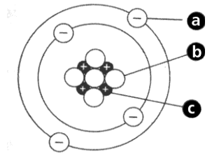
- Fill in the blanks. (7 pts)
 | Subatomic particle | Charge | Relative Mass | Location in atom
a |  | -1
b |  | 0 | 1
c | proton |  |  | nucleus

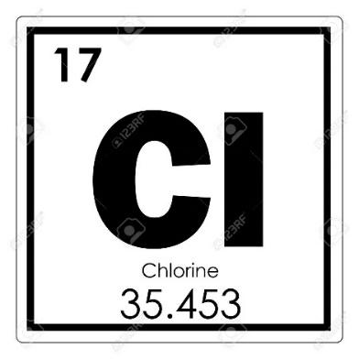
- Looking at the element chlorine (see image), answer the following: (5 pts)
  - What is the atomic symbol? _______
  - What is the atomic number? _______
  - How many protons does it have? ______
  - How many electrons does it have? _______
  - How many neutrons does it usually have? _______
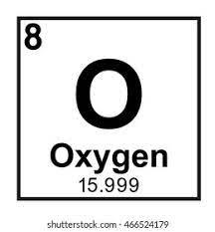
- Calculate the number of subatomic particles in each of the following ions using the pictures below: (6 pts)
 | protons | neutrons | electrons
Be²⁻
O³⁺

- Which statement best defines radioactive isotopes? (1 pt)
- Isotopes that are stable
- Isotopes that are unstable
- Atoms with a positive or negative charge
- Which of these is not a type of ionizing radiation? (1 pt)
  - Alpha particles
  - Beta particles
  - Zeta particles
  - Gamma rays

- Match the type of radiation to the thinnest material that can stop each type of radiation by drawing a line segment connecting them. (3 pts)
- Thick lead or concrete alpha
- Paper beta
- Wood gamma
- The half-life of Rn is 6 days. After how many days is the amount remaining ¼ of the original amount? (1 pt)
- 2 days
- 12 days
- 32 days
- 4 days

- On the periodic table, group 18 (the furthest on the right-hand side), which includes Helium (He) is known as the? (1 pt)

- Alkali earth metals
- Transitional metals
- Noble gasses
- Metalloids

- How many electrons can be in the 1st shell of an atom (s1)? (1 pt)
- 4
- 8
- 16
- 2

- When an element is heated, it emits a distinctive glow, which can be seen with a spectrometer. This is called the ________: (1 pt)
- Heat
- Rainbow
- Atomic light show
- Atomic spectrum

- Distinguish between atomic number and mass number. (2 pts)

- An atom has 43 electrons, 56 neutrons, and 43 protons. What is the approximate atomic mass in atomic mass units? Show your work. (2 pts)

- If someone kept getting the words “isotope” and “ion” confused, how would you explain the difference to them? (2 pts)

- If you double the net force acting on an object, what happens to that object’s acceleration? (1pt)

- If the net force on an object is to remain the same, what happens to the object’s acceleration if we quadruple its mass? (1pt)

- The gravitational force by the Earth on the Moon is the force that keeps the Moon in orbit about the Earth. Does the Moon also exert a force on the Earth? How do you know? (What evidence is there to support this?) In terms of magnitude, how are the forces related? (3pts)

- Suppose Robert and Mike pull on a sleigh. Robert pulls on the sleigh with a force of 30N to the East and Mike pulls on the sleigh with a force of 25N to the West. Draw a force diagram to represent the situation. What is the net force acting on the sleigh? (4pts)

- According to Newton’s Universal Law of Gravitation, what would happen to the gravitational force between the Earth and the Moon if the distance between their centers were doubled? (1pt)

- If a projectile is launched from an angle of 15 degrees with respect to the horizontal, and the projectile is launched from the same height as it lands, what other launch angle will produce the same horizontal range? Which of the two launch angles will produce the greatest altitude? (2pts)

- If the launch and landing heights are the same, what angle maximizes horizontal range? What angle maximizes vertical altitude? (2pts)

- When Paul is pulled to the Earth by gravity, Paul pulls up on the Earth with a force equal in magnitude. True or false and why? (2 pts)

- When the net force acting on an object is zero, the acceleration the object experiences is also zero. True or false and why? (2 pts)

- From the following list of five terms, which TWO quantities affect the air resistance experienced by a moving body through the air? (2 pts)
  - force
  - gravity
  - velocity
  - surface area
  - happiness

- When a skydiver’s weight is balanced by the force of air resistance acting against him, we say that he has reached ____________. (1 pt)
- a state of bliss
- terminal velocity
- escape speed
- maximum acceleration

- If you stand on a scale in an elevator that is accelerating downward, the reading on the scale would be: (1 pt)
- higher than your weight at rest
- lower than your weight at rest
- the same as your weight at rest
- none of the above
- Is there gravity in space? Circle Yes or No and explain. (2 pt)

- Explain the weirdness of water and its importance here on Earth. (4 pt)

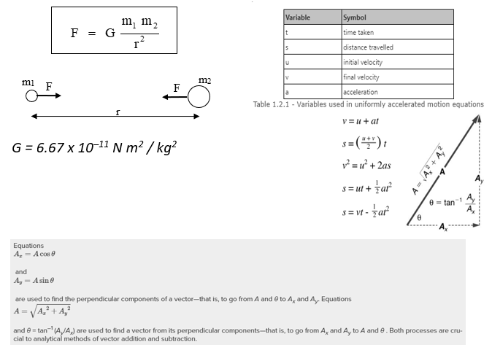
To receive full credit for each problem, include a labeled sketch, identification of each variable, the equations used, show the substitution, and box your final answer with units. For the purpose of these problems, neglect air resistance.
- A 3 kg mass and a 4 kg mass are 3 m apart. How much is the force of gravity of each one on the other? (3 pts)

- A projectile is projected horizontally (at zero degrees) at 5 m/s off a cliff that is 10 m high.
  - How much time will it take to hit the ground? (3 pts)

  - Where will it land in relation to the base of the cliff? (3 pts)

- A ball is thrown with an initial velocity of 20 m/s at angle of 40° to the horizontal.
  - How long will the ball stay in the air (assume it strikes the ground at the same height it was launched)? (3 pts)

  - How far will the ball go before hitting the ground? (3 pts)

  - What will be the maximum height of the ball? (3 pts)

- A projectile is launched from the surface of the Earth at a 45 degree angle at 10,000 m/s. Where will it land? The radius of the Earth is approximately 6,378,000 meters near the equator. (3 pts)

Extra Credit: What have you learned in science this year? What did you find most interesting? What do you think is the most important? Which of these topics would you like to learn more about in the future? (up to 10 pts)

