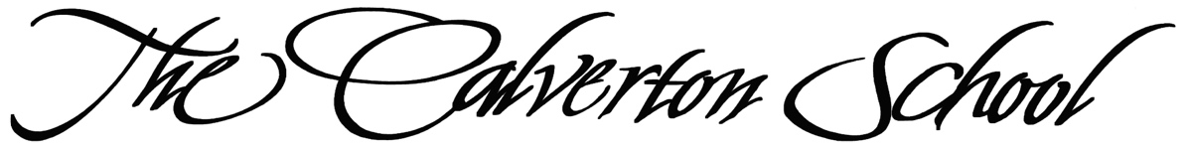

Middle School

Summer Reading, 2023 - 2024
Rising Grade 6 English

Follow the guidelines below.

- Please read Surviving Middle School by Luke Reynolds.

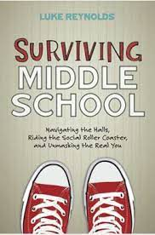
At the end of most chapters, you will find brief writing exercises. Keep a reading journal and complete the writing exercises. [Please note that many of you were given a copy of this book at the fifth-grade recognition.]

- Please read D’Aulaires’ Book of Greek Myths (Paperback) by Ingri and Edgar Parin D'Aulaires.

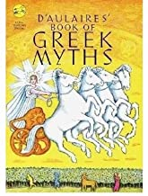
English 6 begins with the study of this book, so read carefully. Keep an artist’s, poet’s, or writer’s journal as you read, filling your journal with your impressions of these stories. The journal will provide you with a record of what you learned from reading the book. Feel free to write, highlight, or underline in your book as you read. This may help you when we work with the myths as part of Unit 1 during the school year. You can find this book on Amazon and other bookstores.

